*4.0*

**Social Media Lead Generation Toolkit for Businesses**

Socioboard helps businesses and brands with a 360o social media lead generation, marketing, customer support, and engagement automation platform.

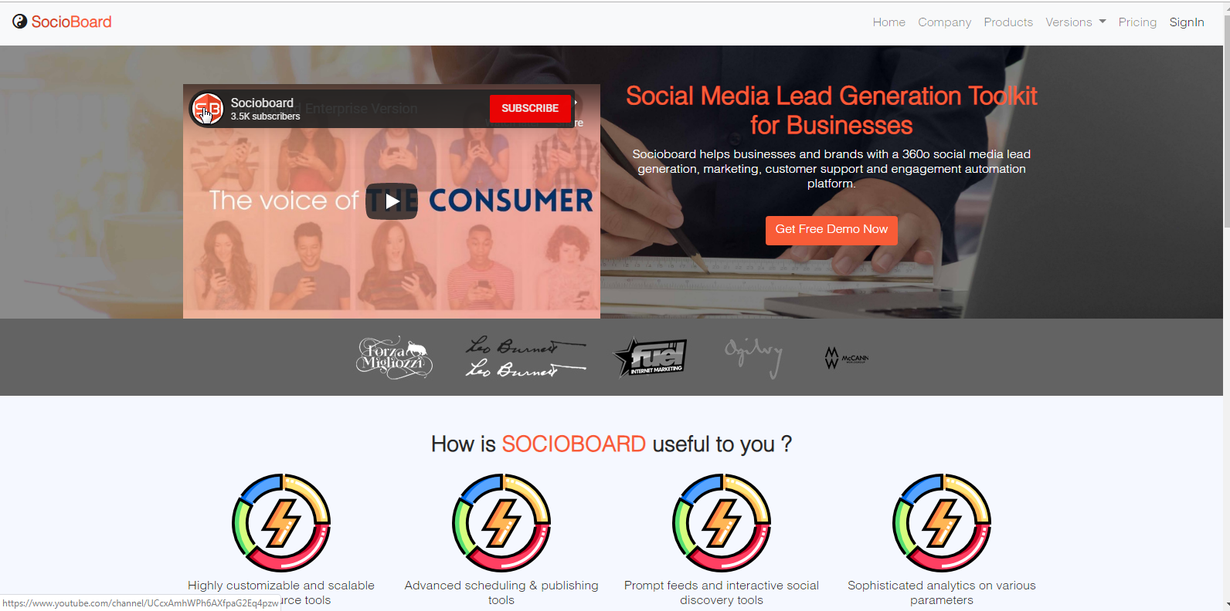

***Socioboard Use Case Document***

***Feature Overview-:***

***Technological Specifications***

*Installation Guide*

Node Installation Guide.

DataBase Setup:

PHP Installation Guide.

***Use Case Descriptions-:***

***Use Case ID 1: Landing page( Registration and login):***

*Use Case ID 1.1: Registration:*

Use Case ID 1.2: Sign in With Credentials

***Use Case ID 2: Dashboard:***

*Use Case ID 2.1: Upgrade the Plan:s*

*Use Case ID 2.2: Add your social profile*

*Use Case ID 2.2: Compose the post*

**Use Case ID 3: Account Feeds:**

*Use Case ID 3.1: Facebook Feed:*

*Use Case ID 3.1: Twitter Feed:*

*Use Case ID 3.1: Instagram Feed:*

*Use Case ID 3.1: Pinterest feed:*

***Use Case ID 4: Publishing :***

*Use Case ID 4.1: Schedule Messages:*

*Use Case ID 4.1: History:*

***Use Case ID 4: Content Studio:***

***Use Case ID 5: Discovery:***

**Social Network API**

# Feature Overview-:

***Description*** *-* Socioboard is the world's first open-source social technology enabler and first open-source product company from India. We build social technology which helps businesses and brands to better understand social media and harness its real power.

Our vision is to provide easy to use tools to businesses and brands which cover 360-degree use cases when it comes to Social Media.

We are building innovative products for various social networks which fill the critical gap - Social Networks were meant for the user’s not for businesses. Our tools and products view Social from a business point of view and fill those gaps which social networks cannot fill exquisitely.

Business should own their social data and they should be in charge of what they want to do with it, generate reports and analyze data to make informed and improved business decisions. This is possible when things are open and businesses have the freedom to choose, we believe open source is a way to make this possible. So that brands and businesses can embrace social technology with an open mind in an open and connected world.

We believe in providing our users with choice, we don’t push useless buggy bloatware to their throat and force them to pay for it.

Our products resonate with our vision to make social technologies more open.

**Features Provided by the current version of Socioboard4.0 are:**

* **Multiple social accounts**
  + Facebook
    - Profile
    - Pages
  + Twitter
  + Instagram
    - Profile
    - Business account
  + Pinterest
  + Youtube
* **Content studio**
  + Imgur
  + Flickr
  + DailyMotion
  + NewsApi
  + Pixabay
  + Giphy
* **Discovery**
  + Youtube
  + Twitter
* **RSS**
* **Board Me**
* **Report**
  + Social accounts Report.
    - Facebook Pages.
    - Twitter profile.
    - Youtube channel.
    - Instagram Business account stats.
  + Team Report.
* **Media Library**
  + Public media.
  + Private Media.
* **Publish**
* **Resocio**
  + Applicable on almost all the content in the Socioboard (like in feeds, content studio, discovery, media library & RSS).
* **Schedule**
  + Day Wise Scheduler.
  + Normal (one time) Scheduler.
* **Notifications**
  + Team Notifications.
  + User Notifications.
* **View Feeds**
  + Facebook Pages posts
  + Youtube Videos
  + Twitter tweets
  + Instagram posts
  + Pinterest Boards and Pins
* **Like and Comments**
  + Facebook page posts
  + Twitter Tweets
  + Youtube Videos
* **Team Management**
  + Team Members and specific Permission to a member
  + Selected accounts in a team
* **Plan Shiftings**
  + Easy to upgrade/downgrade plan
  + Payment details
  + Last payment invoice download ability.

# *Technological Specifications*

**Design:** Html & CSS, Bootstrap, JQuery,

Photoshop etc.

**Programming language:**

❖ **Frontend - PHP**

❖ **Back End** – Node Js

❖ **Framework**– Laravel

**Database:** My SQL and MongoDB

**Version Control:** Git / BitBucket

Mail configuration - Sendgrid

# *Installation Guide*

*Description -In-order to run we need to set up Node and PHP code.*

## *Node Installation Guide.*

*>Download the code from GitHub:*

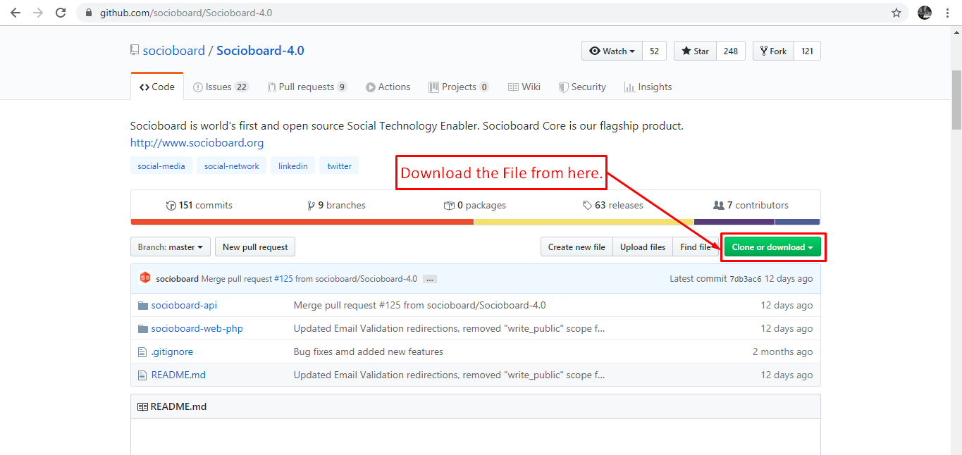

*Open the downloaded folder:*

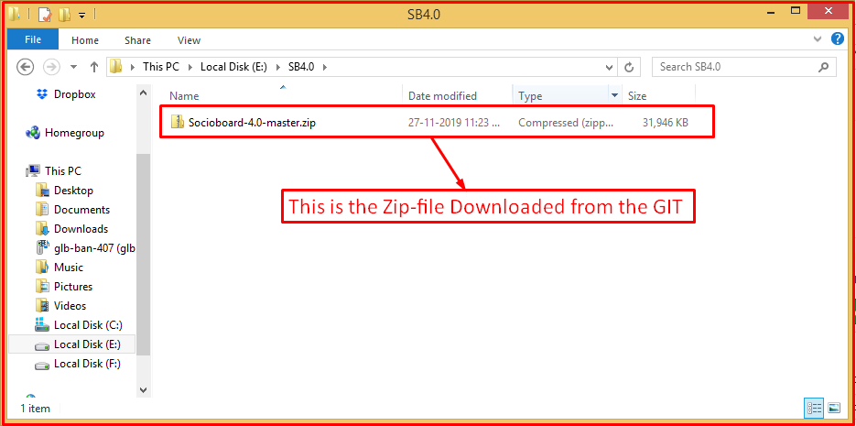

*Unzip the downloaded file:*

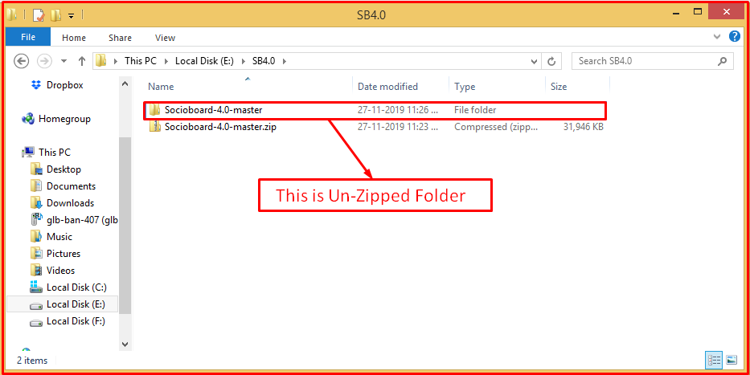

*Open the master folder here you’ll see* ***2*** *subfolders:*

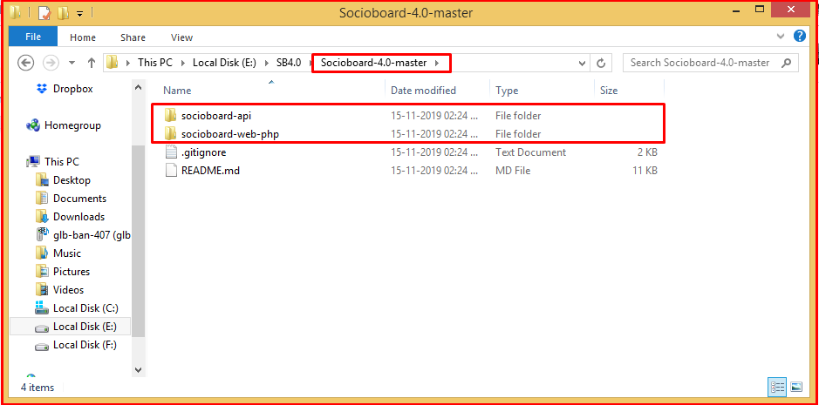

1. ***socioboard-API****, which consists of the Node code.*
2. ***socioboard-web-PHP****, which consists of PHP code.*

*Open the socioboard-API folder( which consists of node code ), and check that it consists of 5 folders.*

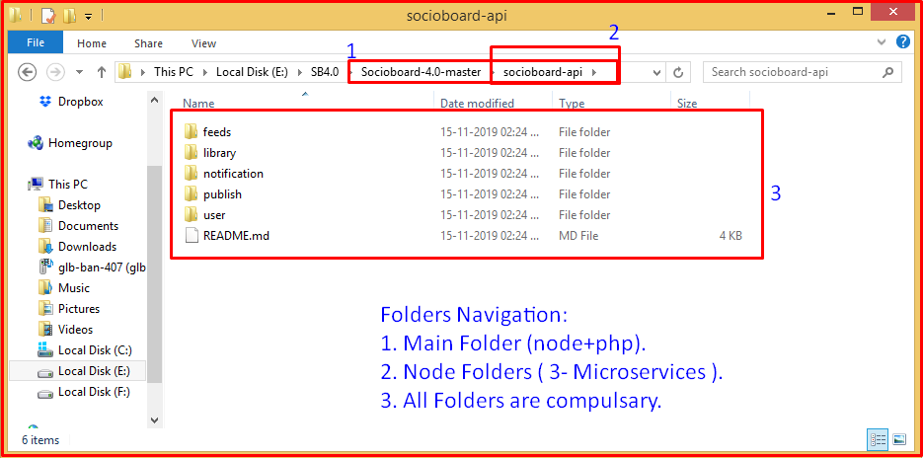

*In these 5 folders, 4 are microservices and 1 is a library for common functionalities.*

*The library folder is “library” named folder - which consists of DB and some common functionalities.*

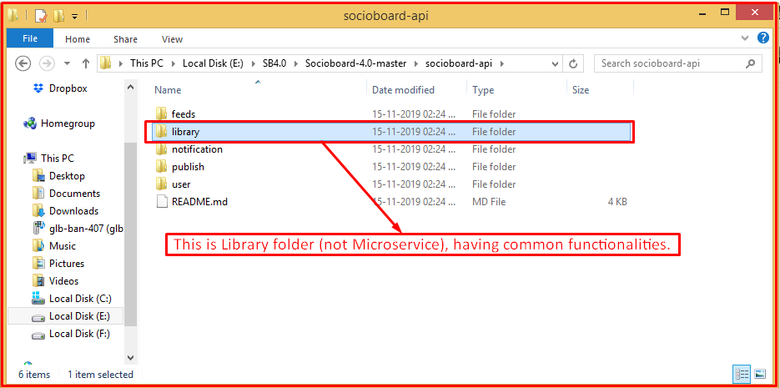

***Microservices folders are*** *:*

1. *User folder*
2. *Publish folder*
3. *Feeds folder*
4. *Notification folder*

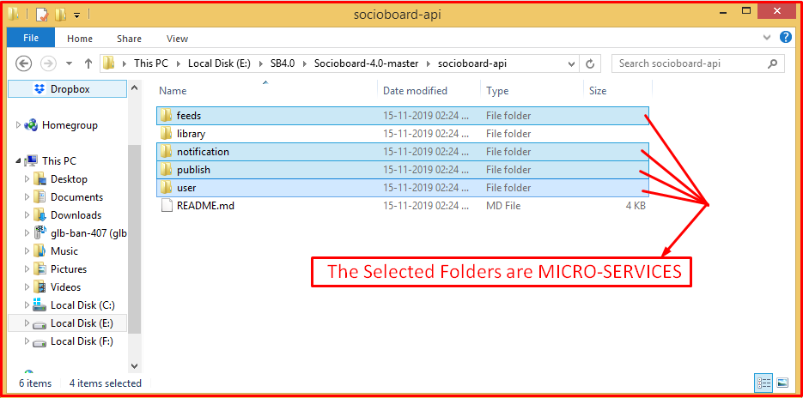

***Now I’ll explain how to set up for Socioboard-API (Node code):***

***Here we follow 2 steps:***

1. ***Node setup in the system.***
2. ***Code setup for running Socioboard.***
3. ***Node setup in the system:***

* *Applications Needed.*
  + *Node*
  + *Xampp (for windows)*
  + *Mongoose*
  + *Nodemon ( I'm using it in this demonstration) for running node.*
* *Steps are as follows:*
  + *Node Installation:*
    - *first, check the node is present on not by typing node -v in cmd prompt if there you'll see version then good to go.*
    - *if not install node from Link: "https://nodejs.org/en/download/" - based on your system config.*
  + *Xampp installation( for windows):*
    - *Link: "*[*https://www.apachefriends.org/download.html*](https://www.apachefriends.org/download.html)*"*
    - *Any Apache server supportive of your system config.*
  + *MongoDB installation:*
    - *Link: “*[*MongoDB for windows(latest)*](https://fastdl.mongodb.org/win32/mongodb-win32-x86_64-2012plus-4.2.1-signed.msi)*”*
    - *Better if you use Robo 3T for GUI.*
  + *Nodemon installation and sequelize Installations:*
    - *in-order to install these - The first check node is installed or not. for that Type ‘node -v’ in command prompt.*
      * *CMD: node -v*

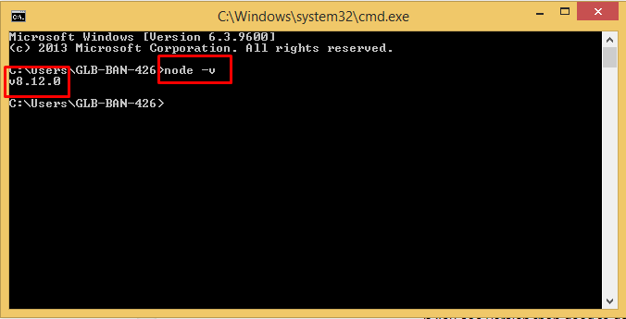

* + - *if You see the version then good to go. Else check the Node installation step.*
    - *install nodemon and sequelize as global, for that use command prompt and use the following commands in it.*
      * *CMD: npm install nodemon -g*
      * *CMD: npm install sequelize-cli sequelize -g*

1. ***Code setup for running Socioboard:***

*In order to set up Node code, all you have to do is follow the below 4 steps.*

* *Installing Packages:* 
  + *We have 5 folders (feeds, library, notification, publish & user)*

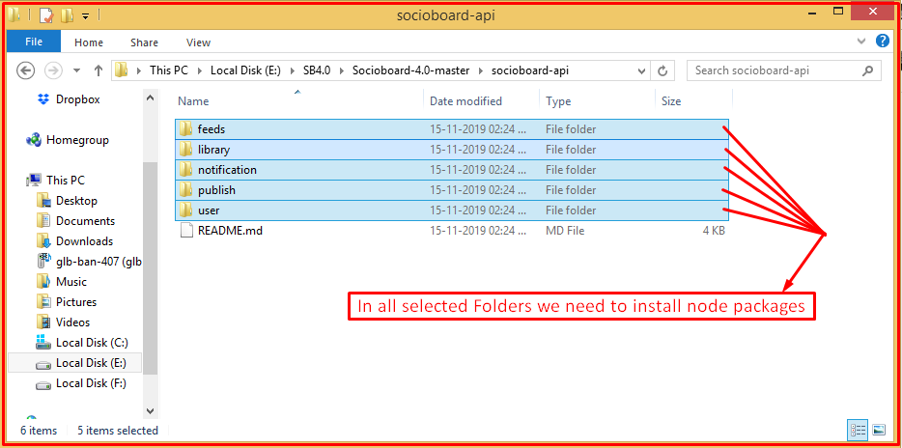

* + *Now I’ll tell how to do in one folder and then do the same for all other folders too.*
    - *First, open a command prompt in that folder,*

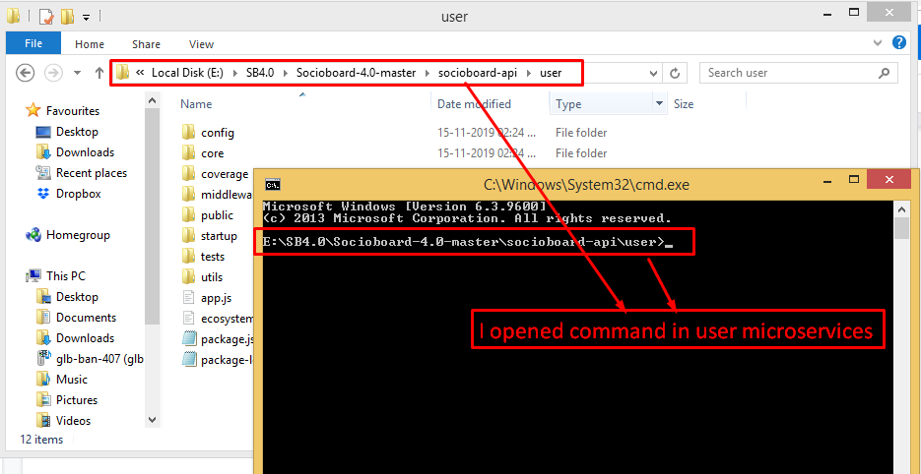

*(I'm showing in user folder)*

*and then type installation command in that command prompt*

* + - * *CMD: npm install*

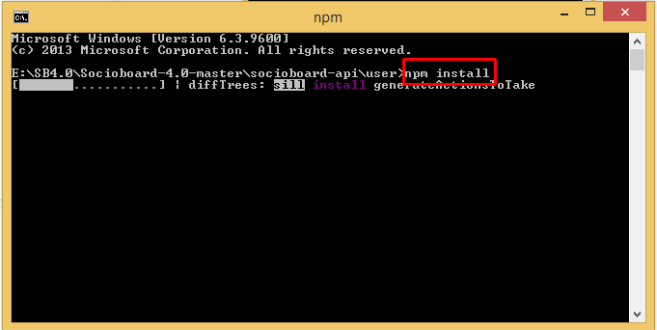

* + - * + *If you see a warning then run “npm audit fix” cmd.*

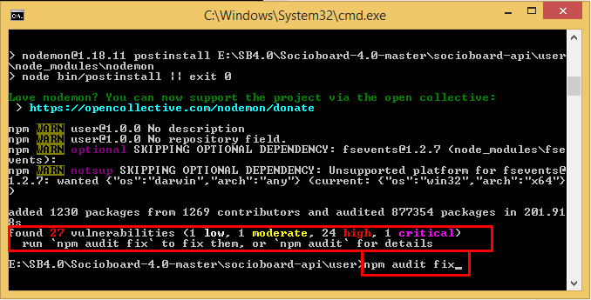

* + *Similarly, do the same process in the rest of the folders also.*

## ***DataBase Setup:***

* + *We are using MySQL and Mongoose Databases.*
    - *Setting up SQL DataBase:*
      * *Before Doing anything first check SQL running or not and set-up the config file.*
      * *Setting up config file:* 
        + *Config file location: (\socioboard-api\library\sequelize-cli\config),*

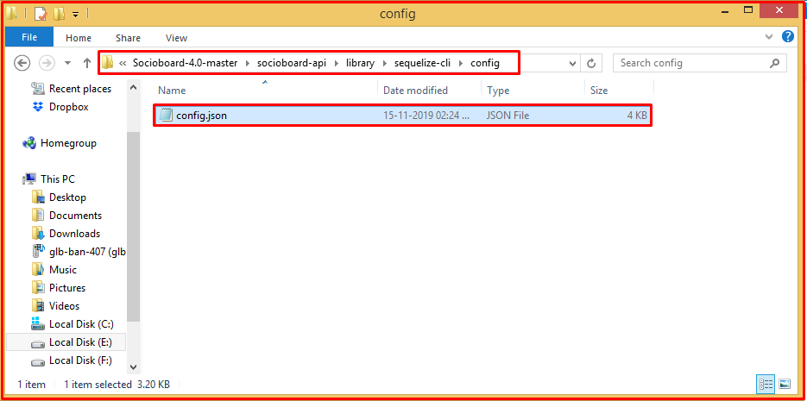

*Open in any editor then go to development Object and assign the proper values to the variables.*

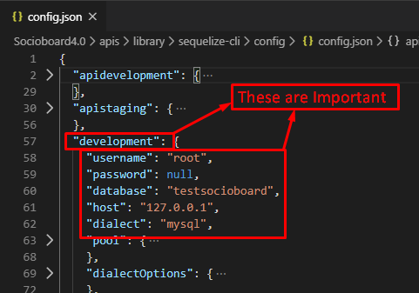

* *Before doing the remaining steps make sure you have that database created and running in the same config location which you’ve updated in the config file.*
* *Go to the sequelize-cli folder (\socioboard-api\library\sequelize-cli) and open a command prompt, then execute the following commands.*

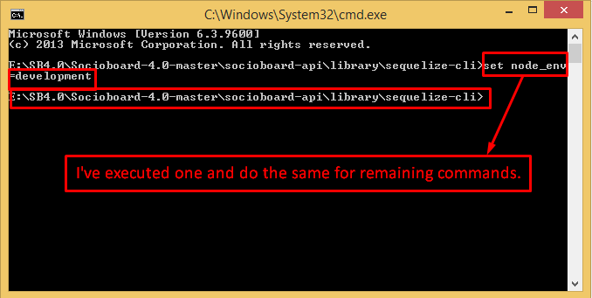

* *CMD: set node_env=development*
* *CMD: sequelize db:migrate*

*Once migration get complete then you can see the DataBase like the below image:*

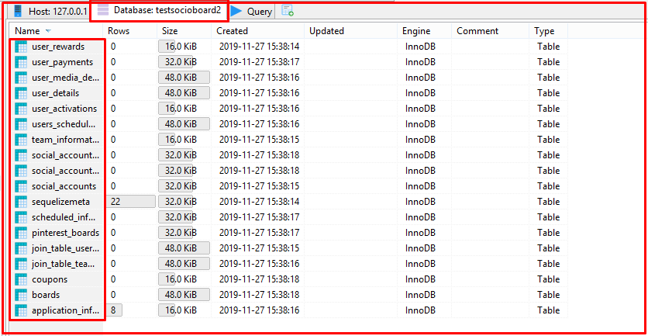

* *CMD: sequelize dB: seed --seed “applicationinfo.js- file name” (which is available in the seeders folder).*

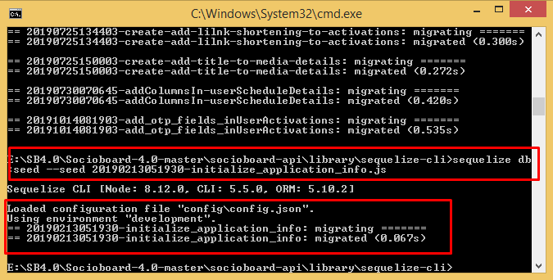

*I got success for Both commands. You also should get this kind of response.*

*Once the seeder completed for application information table you can see the Data like the image below:*

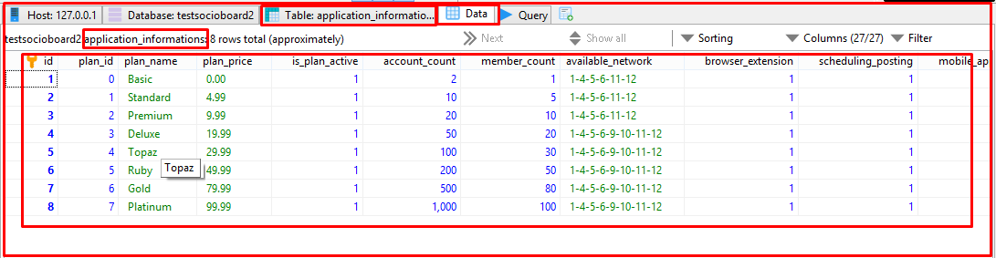

* *After these commands, successful execution for confirmation go and check the Database manually once, so that in future/running time you won’t get any issues.*
* *Setting up Mongoose DataBase:*
  + *Make sure that the mongoose service is running and set the variables in the development.json file (as we are using the development environment to run the Node - it may differ for you if you want to change the environment).*
  + *File location to config MongoDB(\socioboard-api\user\config), here development.json file, and in mongo object set the valid values to the variables.*

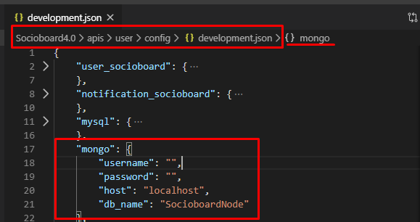

* *Similarly, do it in all 4 microservices folders.*
* *Make sure that you open config files in the config folder and update all mongo objects with proper values and set the proper values of sequelize in the environment object for SQL connection in the config file (sequelize-cli->config->config.json).*
* *Setting up config files:*
  + *In order to run all services properly, we need to set up 2 files in the config folder of each microservice.*
    - *1. Default.json file - in the config folder of each microservice.*
    - *2. development.json ( environment name == development ) - in the config folder of each microservice.*

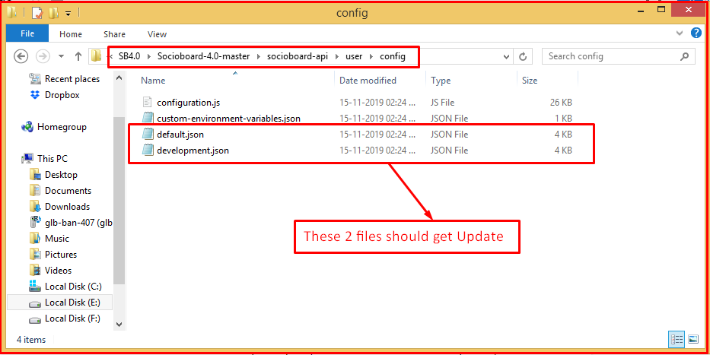

* *Running microservices:*
  + *In order to run the Socioboard4.0 services properly, we need to run all microservices (user, publish, feeds, & notification).*
  + *Here I’ll explain how to run a microservice, then do similar to the remaining microservices.*
    - *First, open a command prompt in a microservice folder, then execute the following commands,*
      * *CMD: set node_env=development (for setting the environment).*
      * *CMD: nodemon app.js (to run the services with the above environment).*

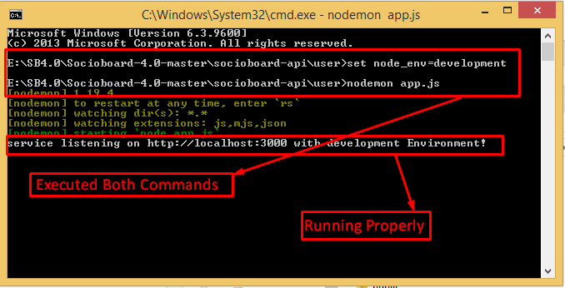

* + - *If it shows a message of running then it’s working properly. Else the failure reason will be logged into a file which is available in the same microservices folder (/public/logs/servicesnameDATE.log file ).*

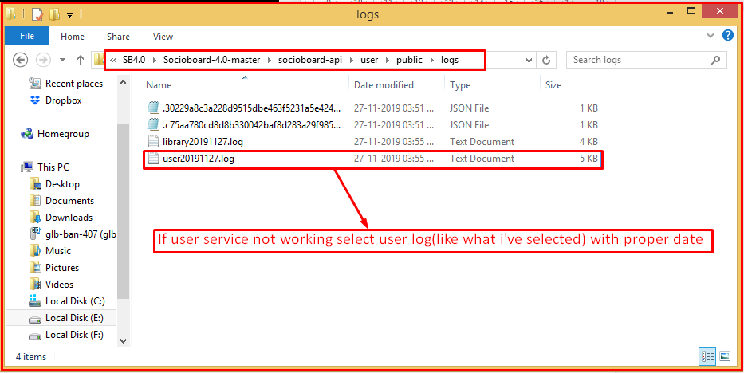

* + *Do a similar process in remaining microservices.*

*After completing all these steps successfully you can test the code using “Swagger-UI” which is inbuilt written in this code.*

*To check all services all you need to do is open a web browser and run the port with explorer route, ex: “*[*http://localhost:3001/explorer*](http://localhost:3001/explorer/#/)*”,*

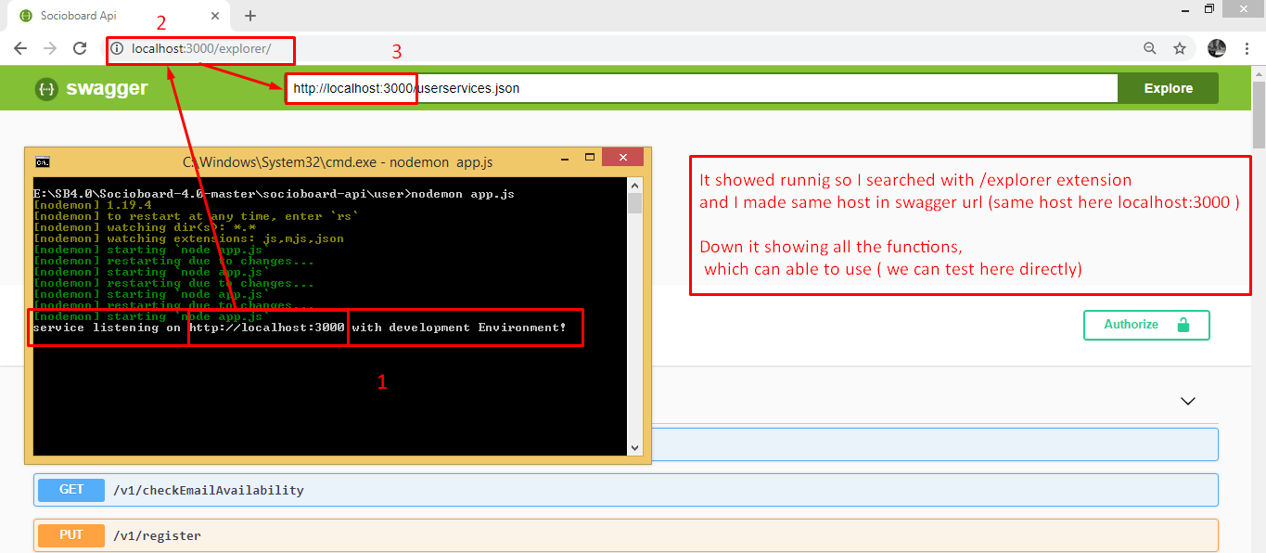

*and similarly test for all microservices.*

## ***PHP Installation Guide.***

*Now I’ll explain how to set up for Socioboard-web-Php (Php code):*

* *First, install the composer in socioboard-web-app folder*

*By executing the command “composer global require laravel/installer”*

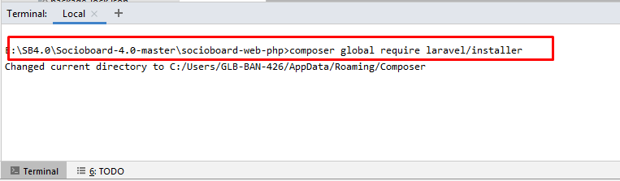

*After successful of composer installation,*

* *Configure .env:*
  + *Rename environmentfile.env to ‘.env’ file. Provide laravel APP_KEY and set APP_URL, which is going to be your host URL.*

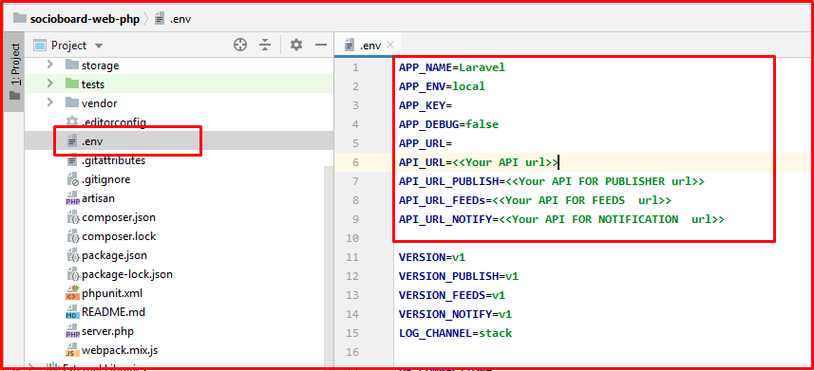

* *Update composer:*
  + *For installing PHP dependencies, update the composer. Use the following command to execute the composer update.*
    - *CMD: composer update*
  + *Before running composer update, make sure .env file is fully valid.*

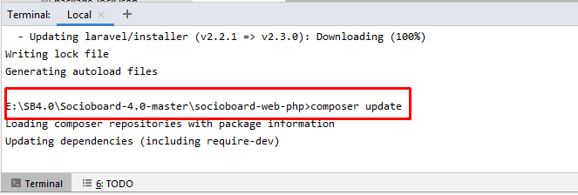

*That’s it, now you can check the site is running or not,*

*I gave the URL as “*[*https://localhost.socioboard.com/*](https://localhost.socioboard.com/)*”*

*If you go to this link we can see the home page, In this code home page is log-in page, so it will show the website as like the below image,*

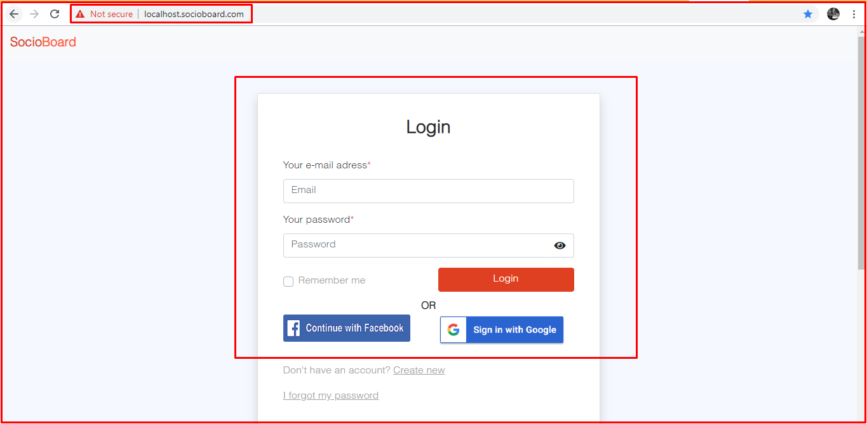

***Video References:***

1. *Node setup in system -* [*Node setup for Socioboard4.0*](http://somup.com/cqjIXAeroO)
2. *Code setup for running Socioboard -* [*Code setup for Socioboard4.0*](http://somup.com/cqjIlTerDW)
3. *Php setup for Socioboard -* [*PHP code setup for Socioboard4.0*](https://screencast-o-matic.com/watch/cqjVlHOGQo)

.

# ***Use Case Descriptions****-:*

## ***Use Case ID 1: Landing page( Registration and login):***

Description - Sign up is required to Log in to your Socioboard account

### ***Use Case ID 1.1: Registration****:*

Step 1- : Registered with email id

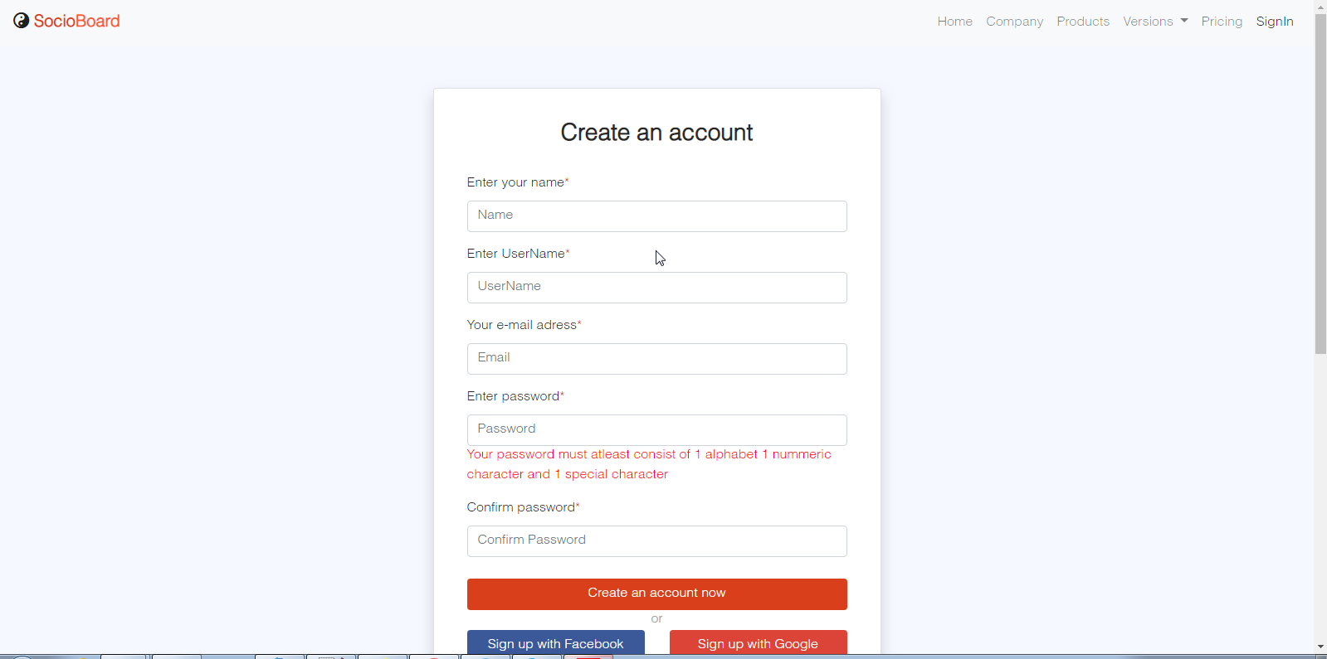

*Step 2- After Registering, the user will get a confirmation mail to the registered mail id. After submitting by*

*‘Click here’ registered account can be Logged in.*

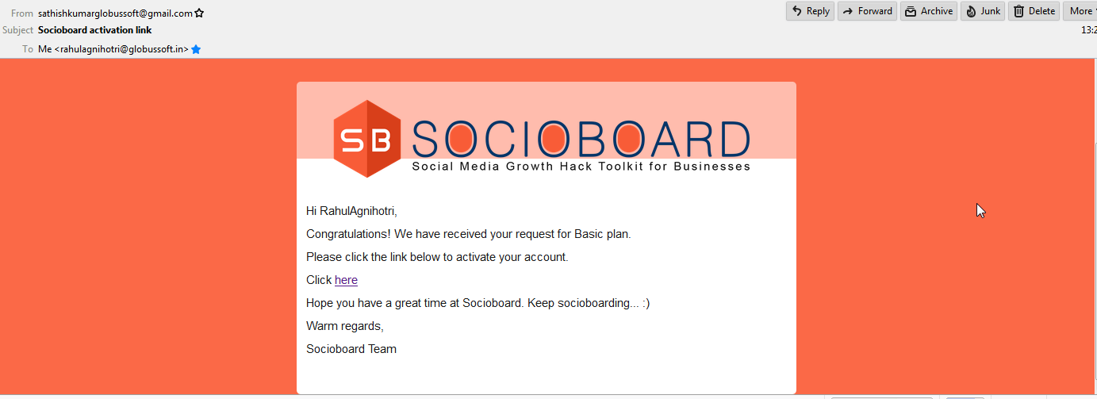

*Social Sign Up*

*User can also sign up through Facebook and Gmail networks, just by clicking on preferred*

*network and by accepting all terms and Conditions to Sign up.*

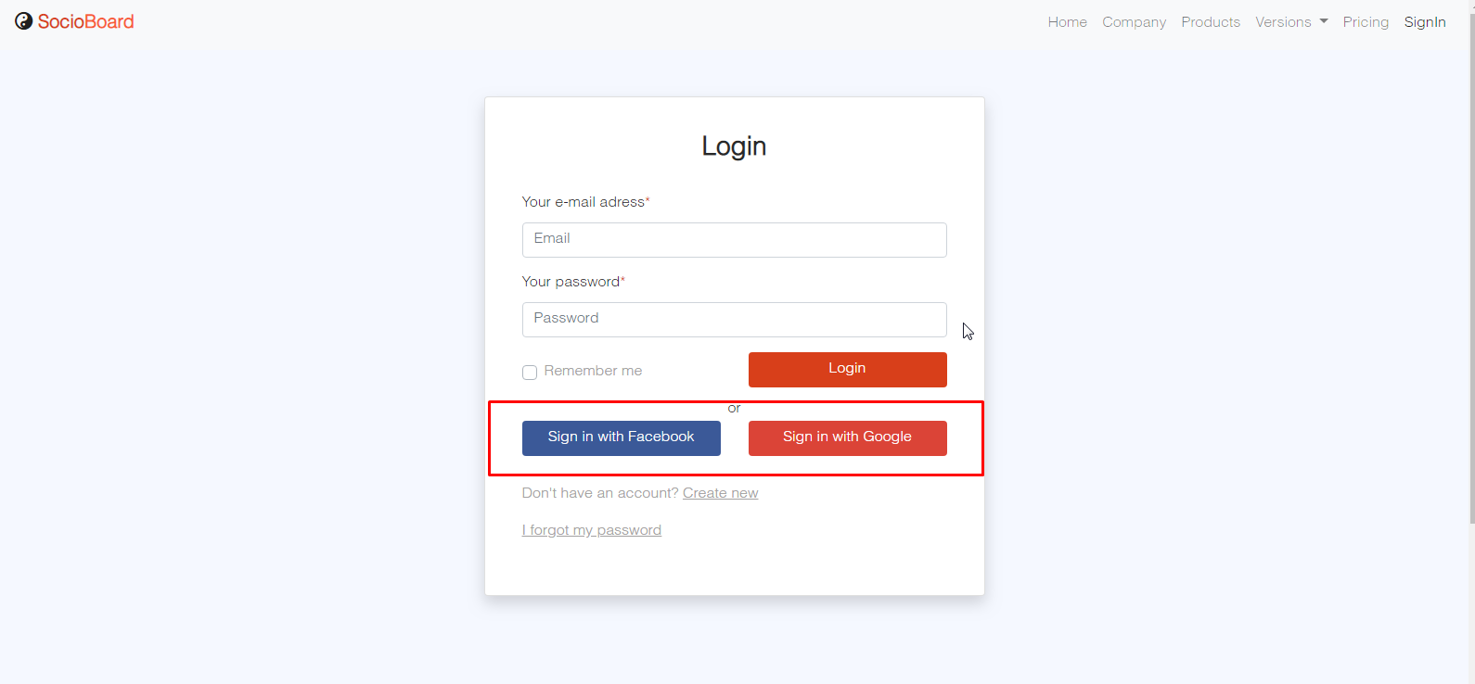

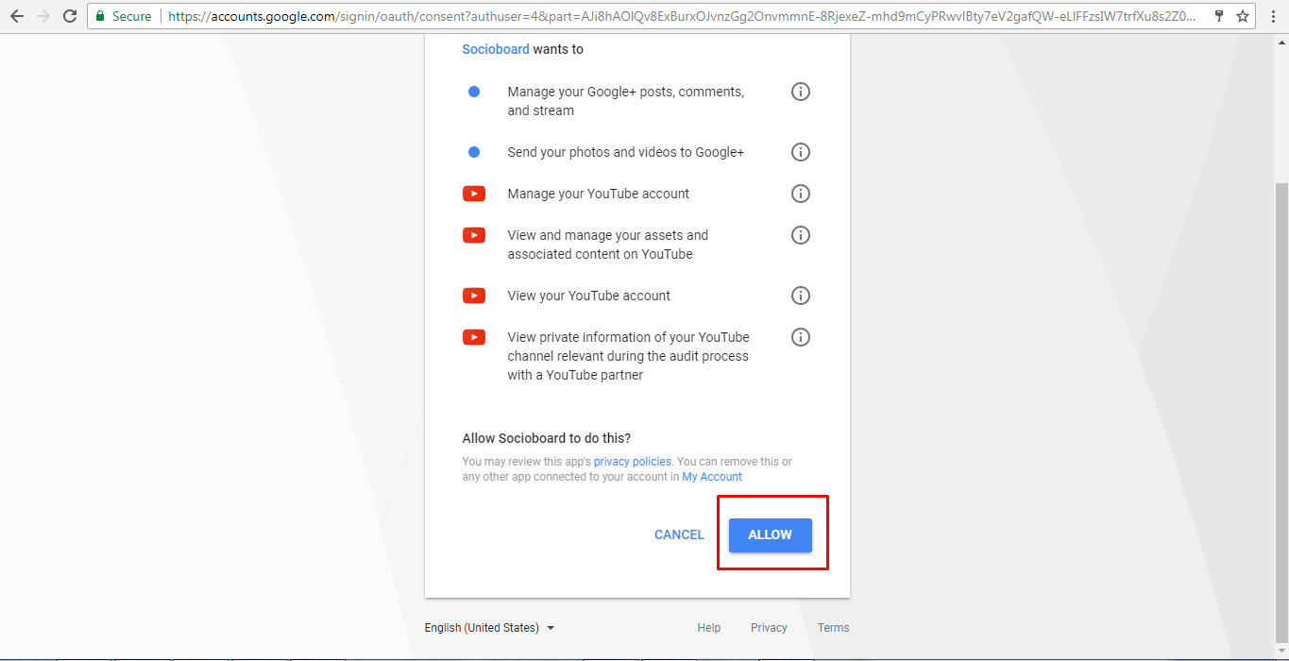

### ***Use Case ID 1.2: Sign in With Credentials***

*Description -By providing Registered Email Id and Password users can Sign in to Socioboard.*

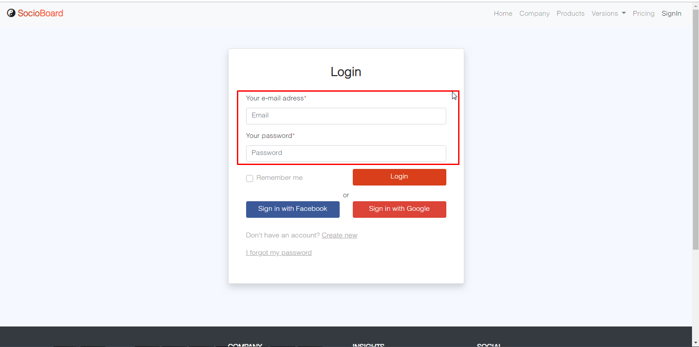

*User can Sign In just by clicking on ‘Sign-in With Google’ or Sign-in With Facebook’ without*

*providing user credentials (Only if Social Sign-in is enabled in Settings).*

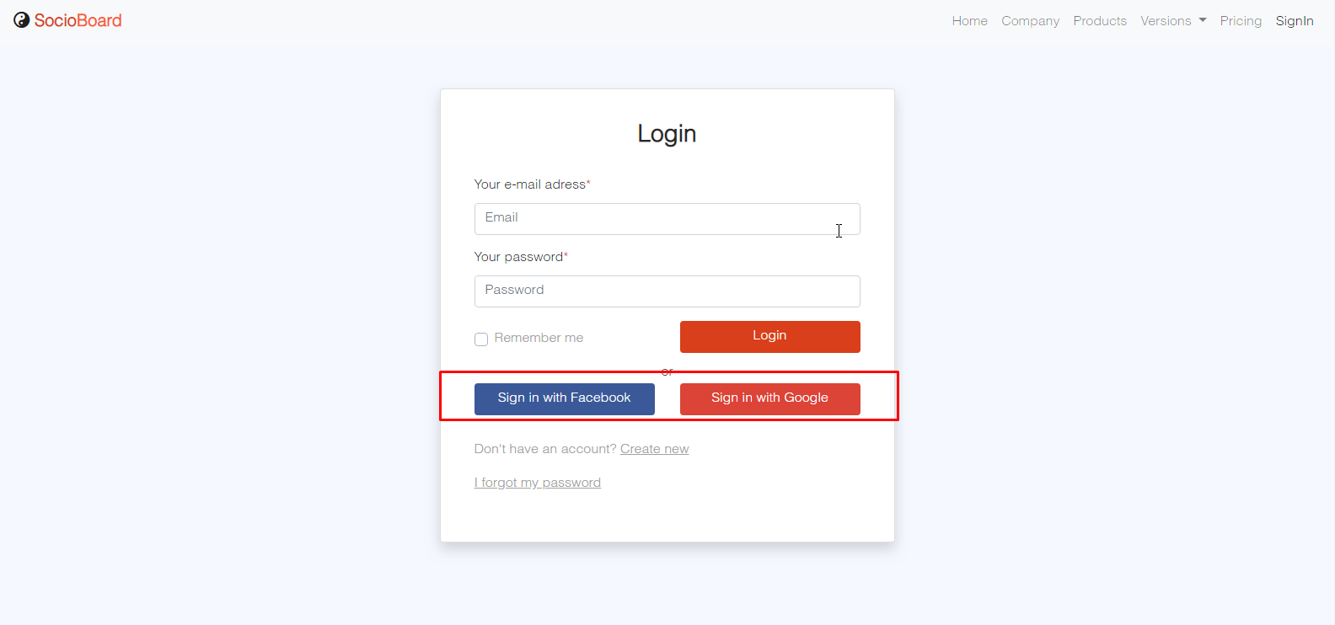

*Account Setting-*

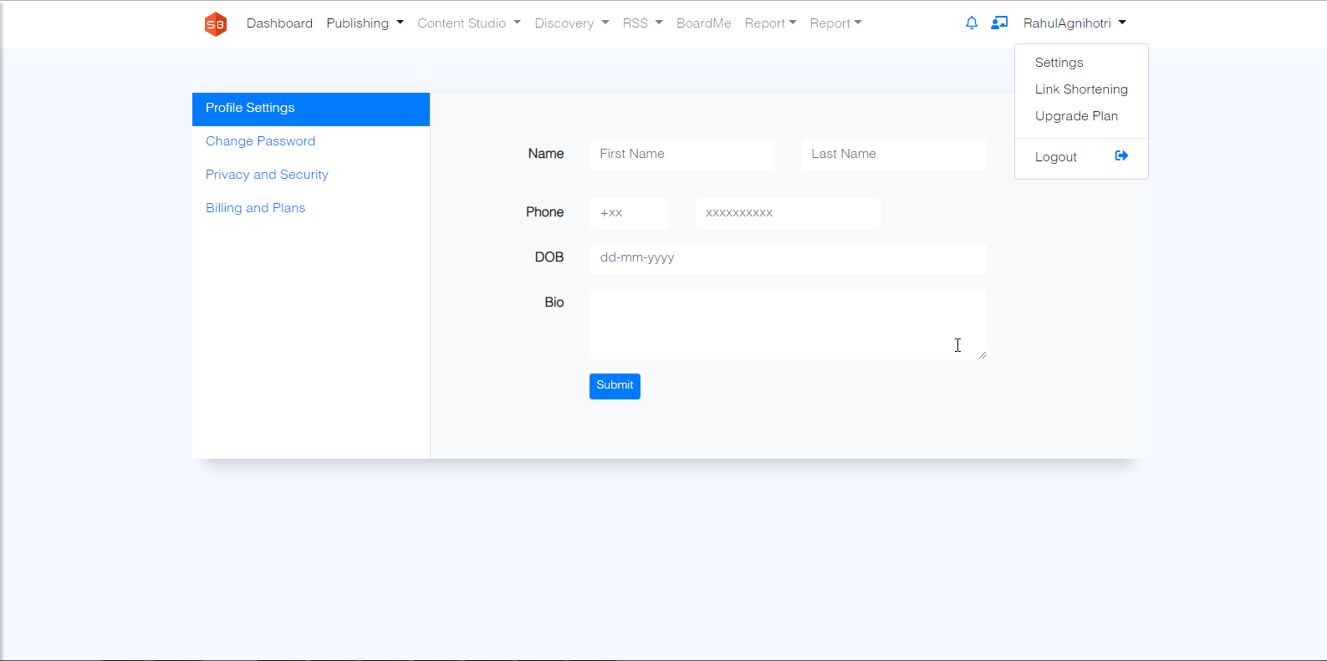

## ***Use Case ID 2: Dashboard:***

***Description****: Once the login done system will assign the basic plan by default*

*If you want to upgrade the plan go to upgrade section and check the plan*

### ***Use Case ID 2.1: Upgrade the Plan****:s*

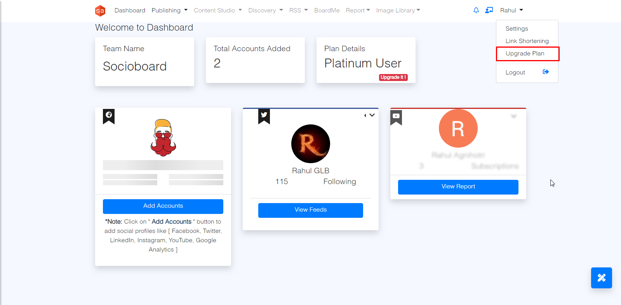

***Pricing Table***

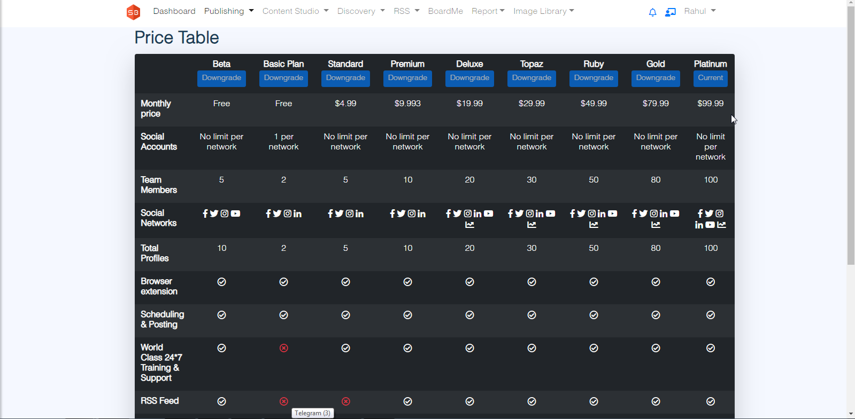

### ***Use Case ID 2.2: Add your social profile***

*In Dashboard, you can add your social profile, compose the message and Automate RSS Feeds*

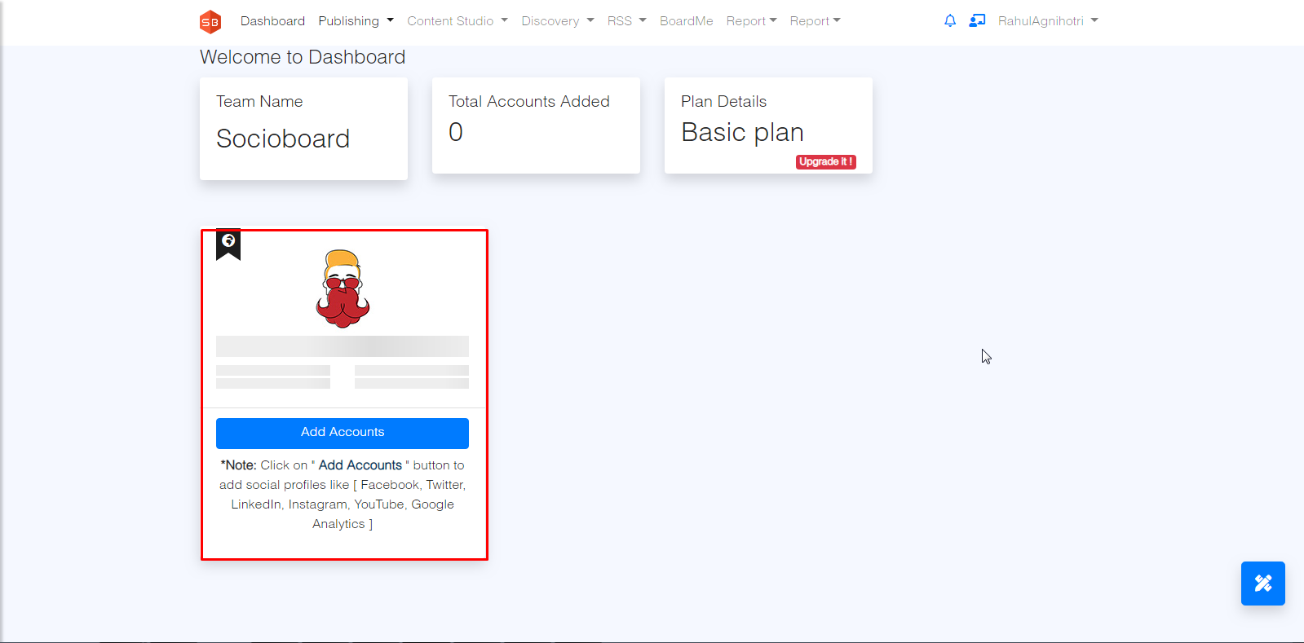

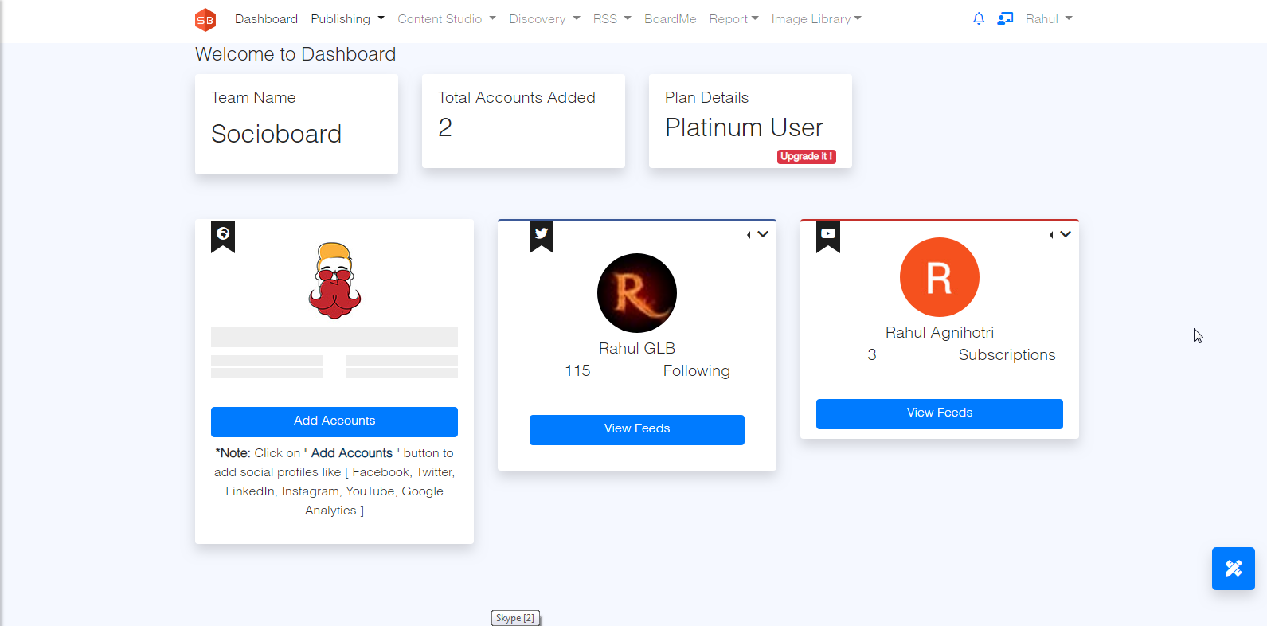

### ***Use Case ID 2.2: Compose the post***

*By using the compose you can send the text, image, gif, video, and w.r.t selected social profiles. You also can save this message in Draft.*

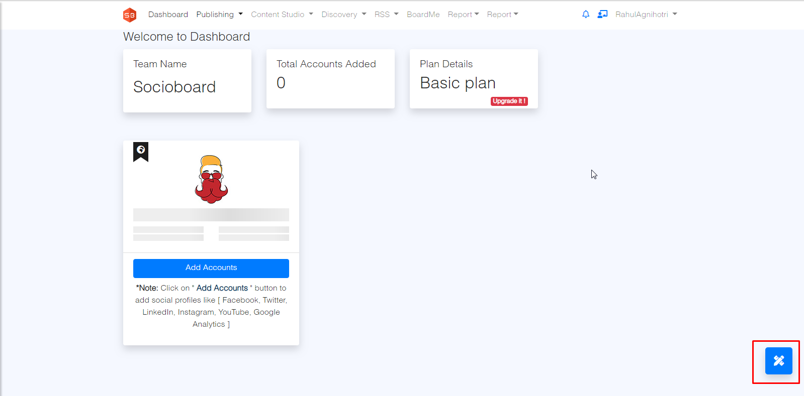

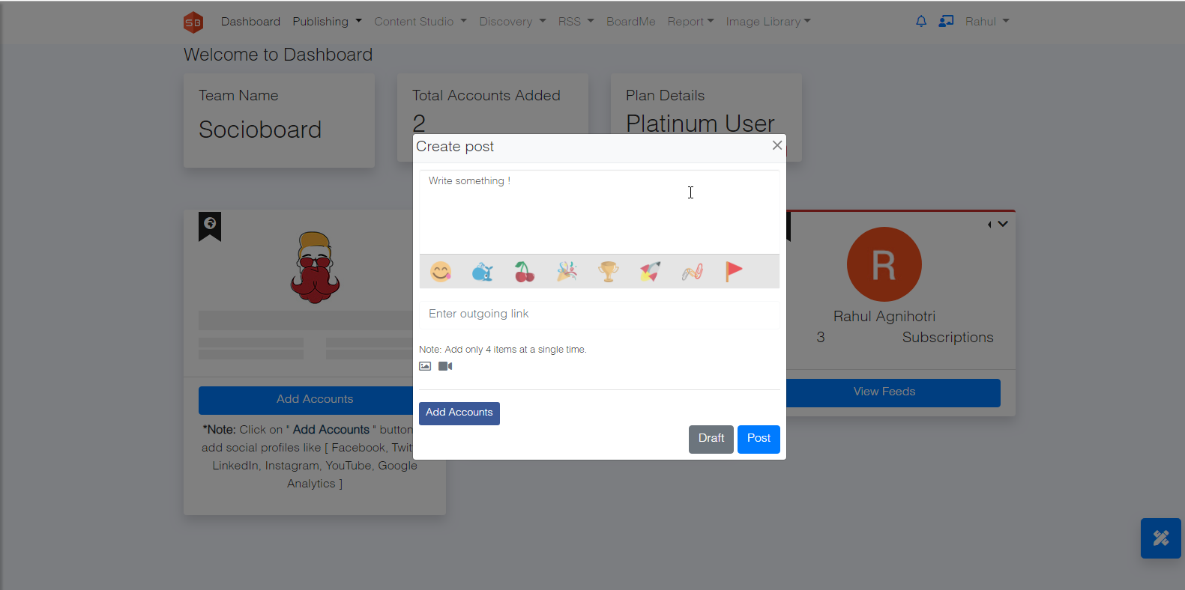

## ***Use Case ID 3: Account Feeds:***

*In “View Feeds” you can see all the posts of the respective profile which you added in socioboard.*

*Facebook., Twitter,.Instagram, YouTube, LinkedIn, Google Plus, Pinterest*.

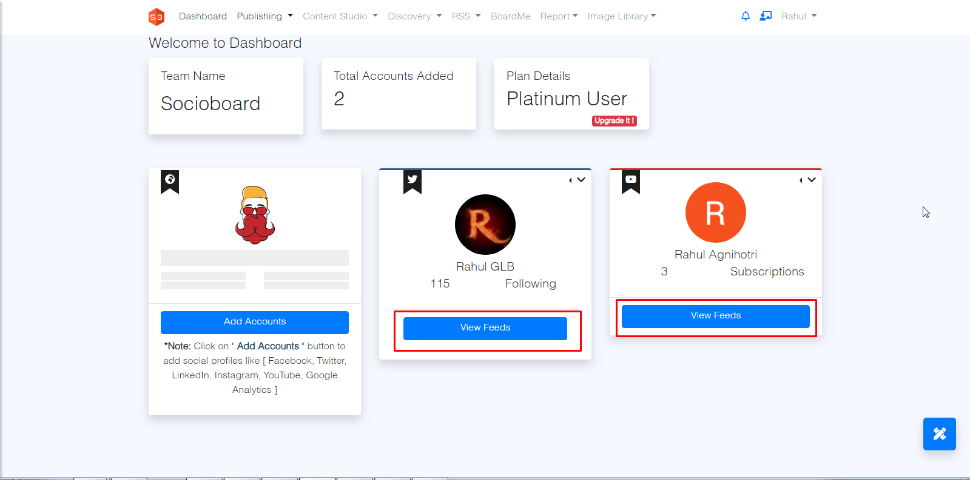

### ***Use Case ID 3.1: Facebook Feed:***

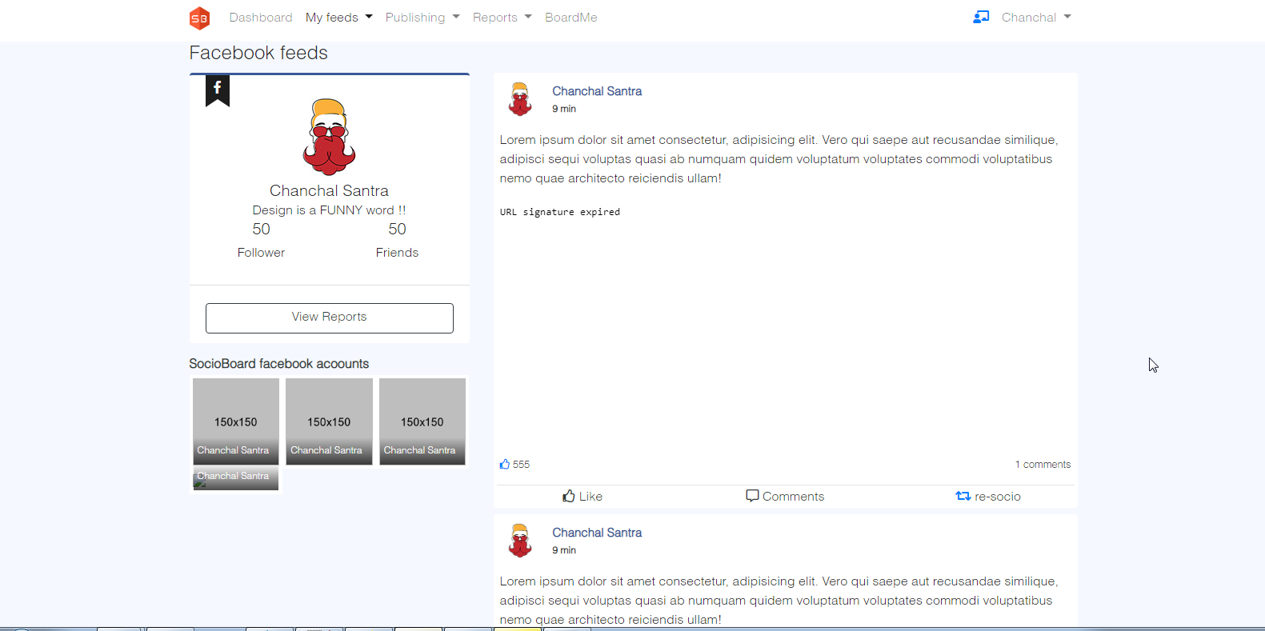

### ***Use Case ID 3.1: Twitter Feed:***

**Description:** You can see your followers and following tweets. In addition, you can perform like, comment Re-socio, on the particular tweet.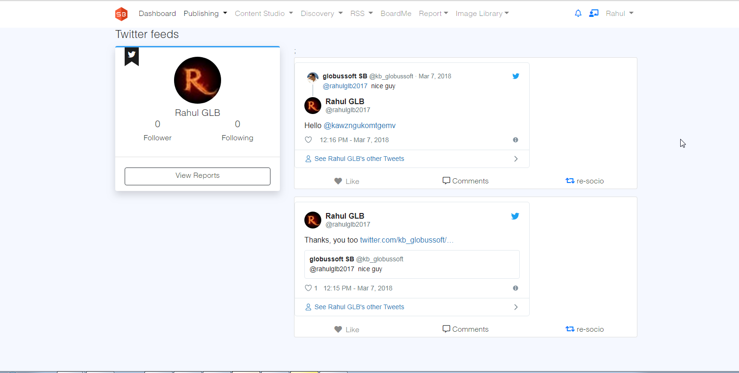

***Report- Users can get the following twitter reports***

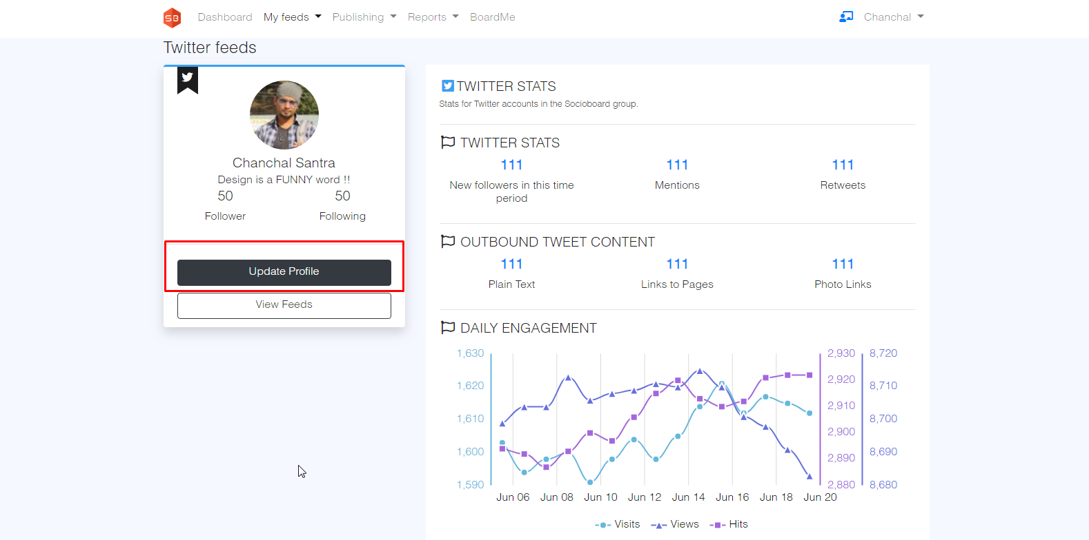

***Where users can get details about Followers, Followings, Retweets, Mentions***

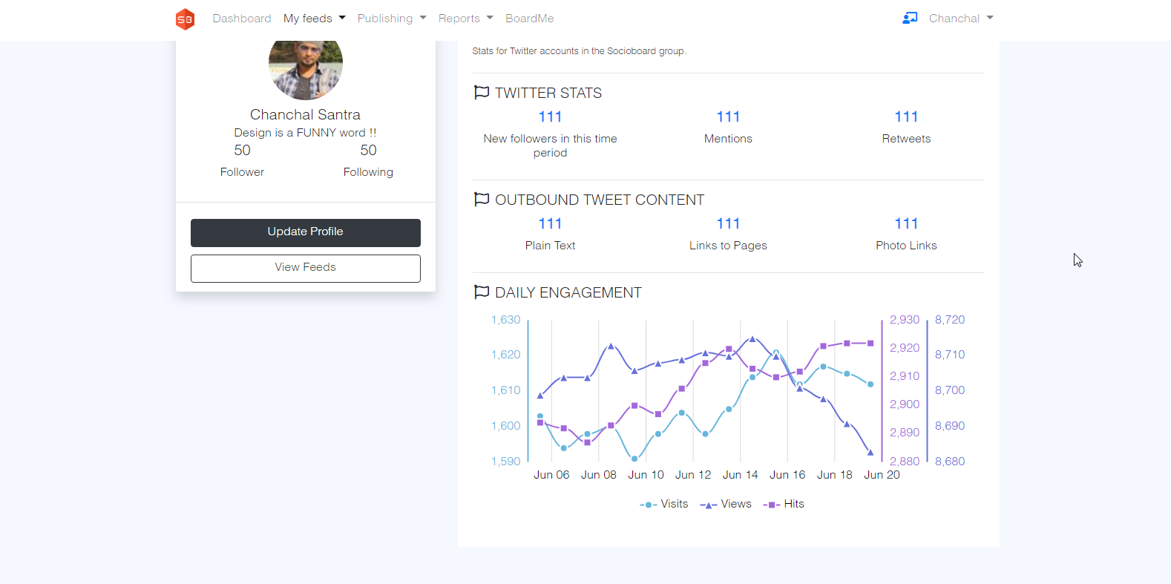

### ***Use Case ID 3.1: Instagram Feed:***

**Description:** You can see the feed report about the Instagram account.

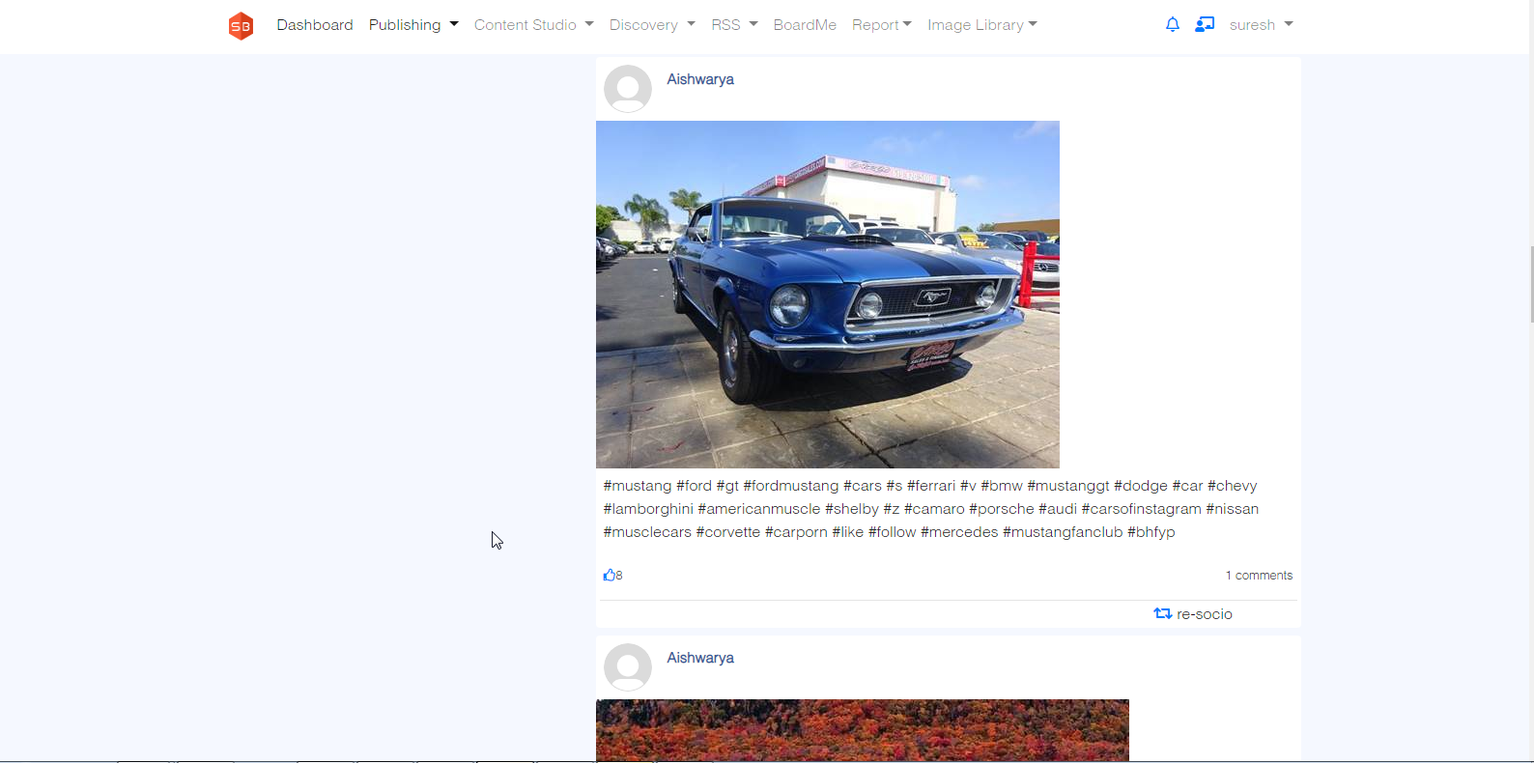

### ***Use Case ID 3.1: Pinterest feed:***

**Description:** You can see your followers and following tweets. In addition, you can perform like, comment Re-socio, on particular tweets.

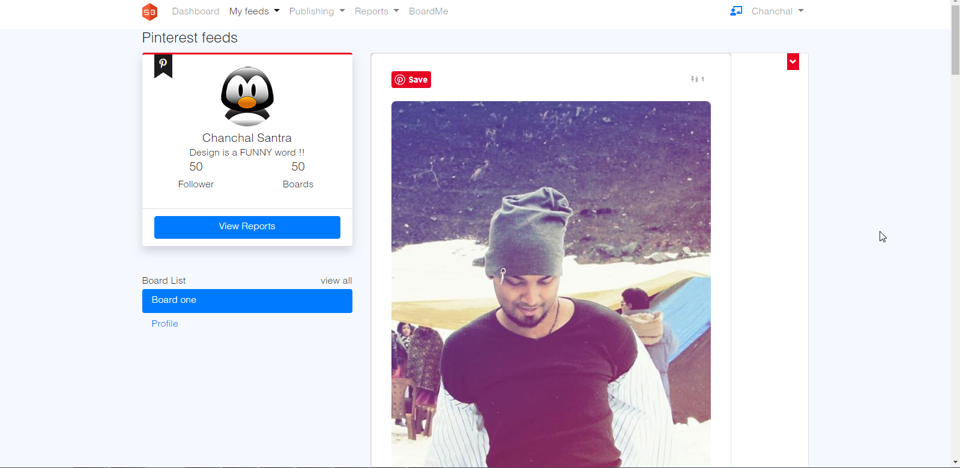

***Report- Users can get the following twitter reports***



***Where users can get details about Followers, Followings, Retweets, Mentions***



## ***Use Case ID 4: Publishing :***

***Description:*** *Using Socioboard publishing tool, a user can “Schedule Messages”, save them to “Drafts”,*

*maintain “SocioQueue” where they can edit or delete their Scheduled Messages and can check*

*“Calendar view” where they can see the detailed list of posts scheduled with date and time.*

### ***Use Case ID 4.1: Schedule Messages:***

***Description:*** *Two types of schedule Normal schedule post and Day wise schedule. Users Can Schedule Messages here by ‘Selecting Profiles’ which they need to post. By Giving a*

*1.Message in ‘Type Your Message Here’ Field*

*2. Select a file to post in the ‘Select Your File’ field, by setting a date and Time to Schedule.*

*3. By clicking on ‘Schedule Post’, the post will be scheduled successfully.*

*4. By clicking on ’Save to Draft’, the post will be saved in drafts*.

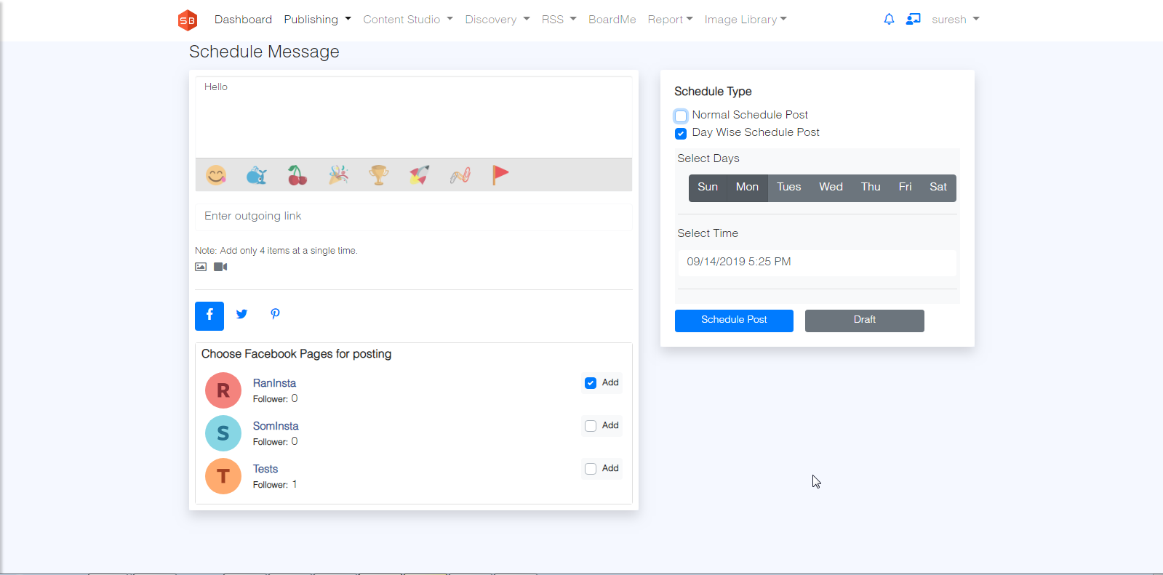

### ***Use Case ID 4.1: History:***

*Description -: User can watch the history of the post in a different section for all social account   
Note- : SocioQueue,Daywise,Draft,History*

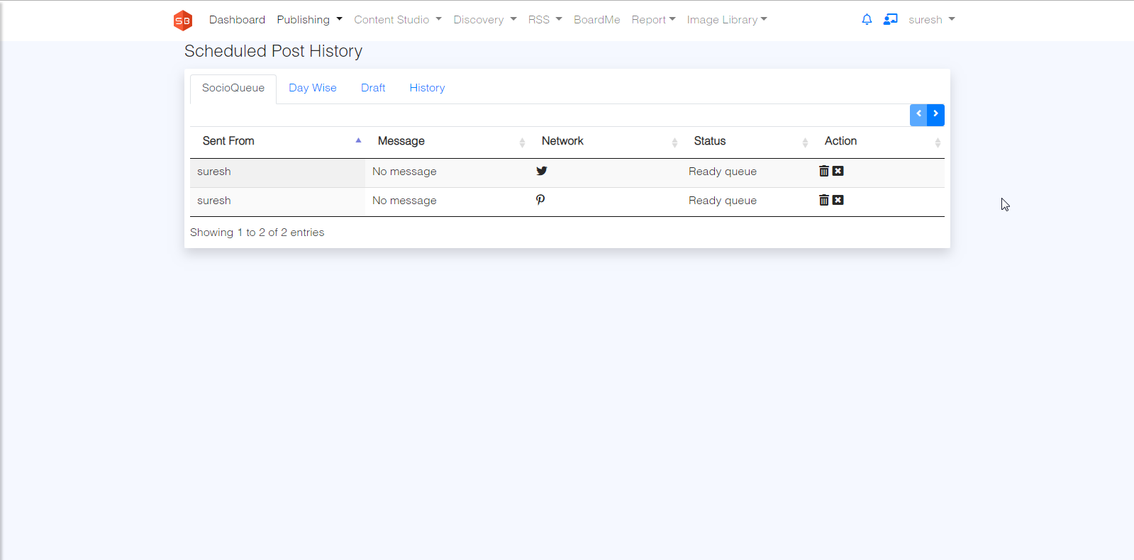

## ***Use Case ID 4: Content Studio:***

***Description:*** *In this Module user will get details about ‘Most shared’ Feeds from Flickr, Imgur, Dailymotion, Newsapi and* Pixabay, and Giphy *Networks. The User can also Search for feeds by giving a keyword.*

*By Clicking on socio, the selected feed by the user can be Posted in the user*

*profiles.*

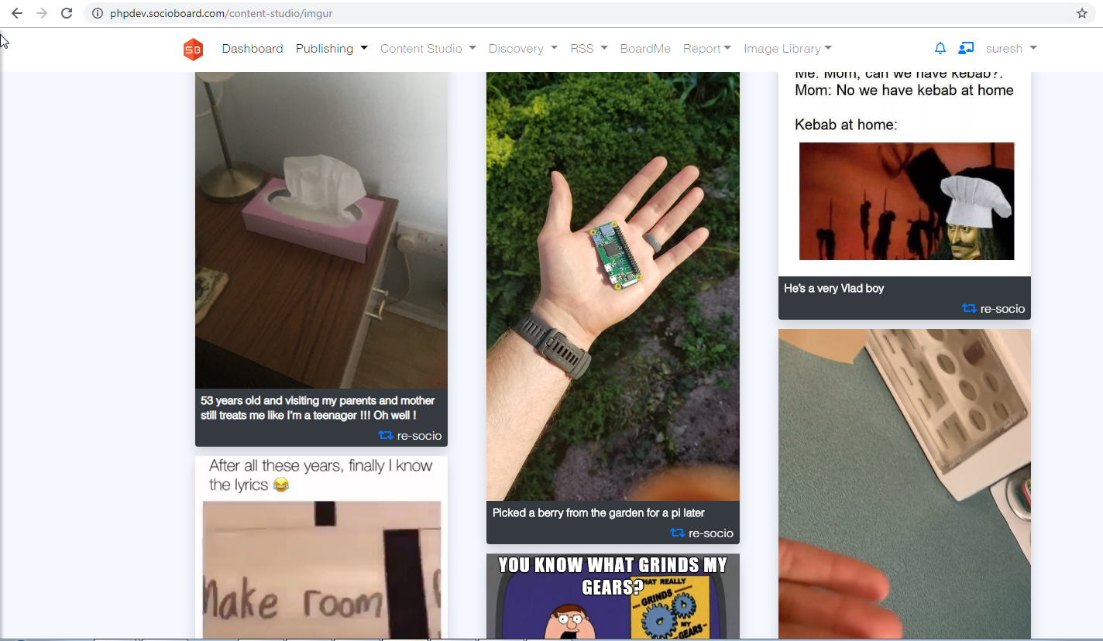

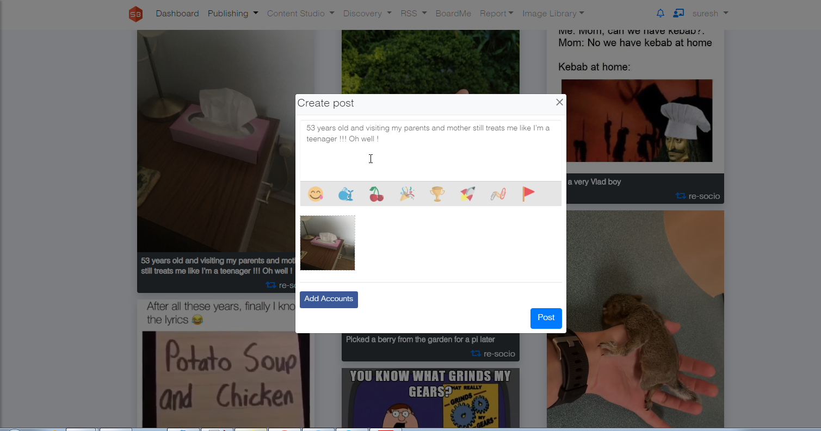

## ***Use Case ID 5: Discovery:***

*Description: Using ‘Discovery’, the user can ‘Search’ by giving Keywords, and can find ‘Group Post’ of similar interests*

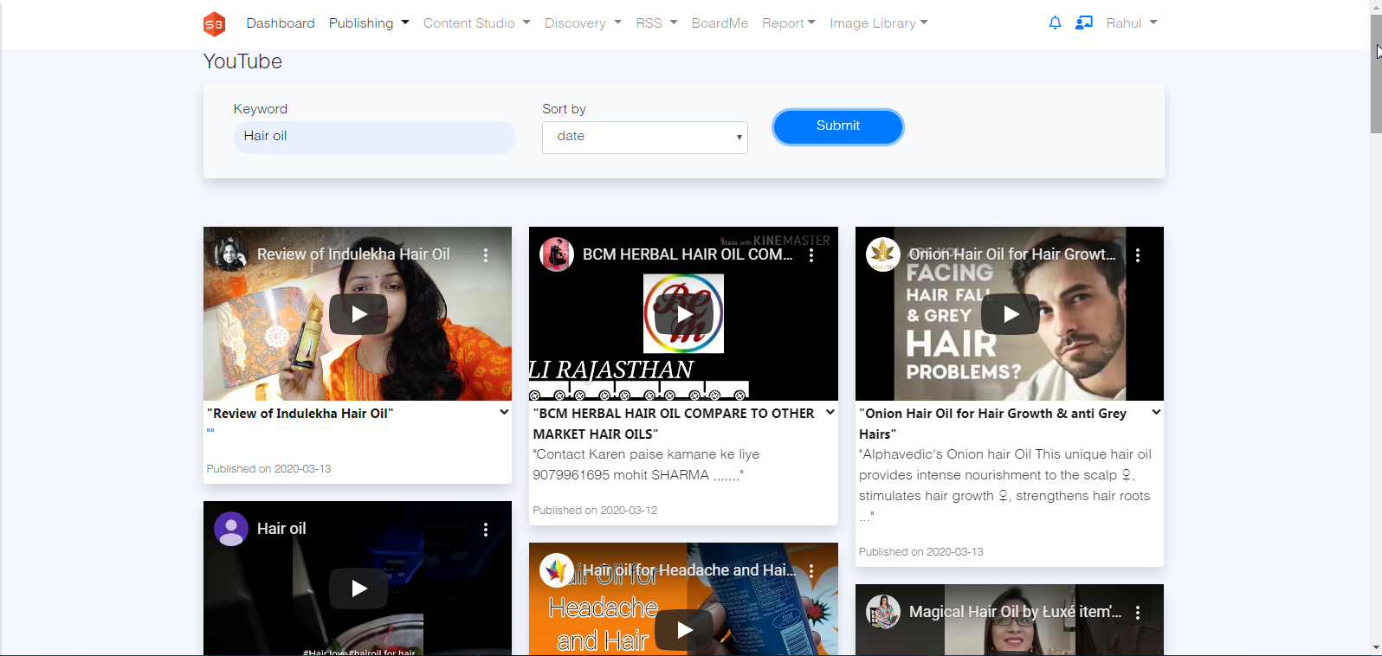

# *Social Network API*

***Facebook graph-API (v3.3):***

1. ***forgetting the Page Feeds and displaying on ViewFeeds functionality***

*API :- GET, https://graph.facebook.com/v3.3/{page-id}/feed*

1. ***for getting accessToken of an account***

*API :- GET, https://graph.facebook.com/v3.3/oauth/access_token*

*parameters: client_id: this.facebook_api.app_id,*

*redirect_uri: this.facebook_api.fbprofile_add_redirect_url,*

*client_secret: this.facebook_api.secret_key,*

*code: code*

1. ***for extending accessToken of a profile***

*API :- get, https://graph.facebook.com/v3.3/oauth/access_token*

*parameters: client_id: this.facebook_api.app_id,*

*client_secret: this.facebook_api.secret_key,*

*grant_type: 'fb_exchange_token',*

*fb_exchange_token: accessToken*

1. ***for getting account/profile details***

*API :- GET, https://graph.facebook.com/v3.3/me?*

*parameters: access_token=accessToken*

1. ***for getting pages details and their access tokens***

*API :- GET, https://graph.facebook.com/v3.3/me/accounts?*

*parameters: access_token=accessToken*

1. ***for publishing posts in facebook pages***

***-- For TEXT post:***

*API :- POST, https://graph.facebook.com/v3.3/{pageID}/feed?message={message}*

*parameters: access_token=accessToken*

***-- for IMAGE's post:***

*here 2 things, 1-upload image, 2-publish the content with uploaded image id's*

***1. Uploading images:***

*API :- POST, https://graph.facebook.com/v3.3/{pageID}/photos?*

*parameters: message: message,*

*Source: images (readStream),*

*published: 'false'*

***2. Publishing***

*API :- POST, https://graph.facebook.com/v3.3/{pageID}/feed?*

*parameters: message: message,*

*attached_media: attachmentDetails(id's of response from the upload), access_token=accessToken*

***-- for LINK post:***

*API :- POST, https://graph.facebook.com/v3.3/{pageID}/feed?*

*parameters: link: link,*

*message: message,*

*access_token=accessToken*

***-- for VIDEO post:***

*API :- POST, https://graph.facebook.com/v3.3/{pageID}/videos?*

*parameters: description: message,*

*Source: video,*

*access_token=accessToken*

***-- for LIKE a post:***

*API :- POST, https://graph.facebook.com/v3.3/${pageId}_${postId}/likes?type=like*

*parameters: access_token=accessToken (page access Token)*

***-- for COMMENT on a post:***

*API :- POST, https://graph.facebook.com/v3.3/${pageId}_${postId}/comments?message=${encodedComment}*

*parameters: access_token=accessToken (page access Token)*

1. ***for getting INSIGHTS (reports of daily activities)***

*API :- GET, https://graph.facebook.com/v3.3/me/insights?*

*parameters: access_token=accessToken (page access Token)*

*date_preset=today(any valid-value)*

1. ***for getting facebook page stats / profile stats***

*API :- GET, https://graph.facebook.com/v3.3/me?*

*parameters: access_token=accessToken (page access Token / profile access token)*

*=================* ***INSTAGRAM BUSINESS*** *==================*

1. ***for getting instagram business account stats / ACCOUNT***

*API :- GET, https://graph.facebook.com/v3.3/me?*

*parameters: access_token=accessToken (instagram business access token)*

*( fields vary from the request)*

1. ***for getting media from the Instagram Business account***

*API :- GET, https://graph.facebook.com/v3.3/${instagramBusinessAccountID}/media?*

*parameters: access_token=accessToken (instagram business access token) + fields*

1. ***for getting the details of a particular instagram business post***

*API :- GET, https://graph.facebook.com/v3.3/${mediaID}/media?*

*parameters: access_token=accessToken (instagram business access token) + fields*

1. ***for getting pages connected with INSTAGRAM BUSINESS***

*API:- GET, https://graph.facebook.com/v3.3/me/accounts?*

1. ***for instagram business insights***

*API :- GET, https://graph.facebook.com/v3.3/${instagramBusinessSocialId}/insights?*

*parameters: access_token=accessToken (instagram business access token) + fields*

1. ***for getting comments of a particular post of instagram business account***

*API :- GET, https://graph.facebook.com/${fbversion}/${mediaId}/comments?*

*parameters: access_token=accessToken (instagram business access token) + fields*

1. ***for WEBHOOKs subscription***

*API :- POST, https://graph.facebook.com/${AccountsocialId}/subscribed_apps?*

*parameters: access_token=accessToken (instagram business access token) + fields*

*-- for WEBHOOKs un-subscription*

*API :- DELETE, https://graph.facebook.com/${AccountsocialId}/subscribed_apps*

*parameters: access_token=accessToken (instagram business access token) + fields*

1. ***for getting the accessToken***

*API :- GET, https://api.instagram.com/oauth/access_token*

*parameters: code=${code}&redirect_uri=${redirect_url}&client_id=${client_id}&client_secret=client_secret}&grant_type=authorization_code*

1. ***for getting profile details***

*API :- GET, https://api.instagram.com/v1/users/self/*

*parameters: access_token=accessToken*

1. ***forgetting the feeds of an Instagram profile***

*API:- GET, https://api.instagram.com/v1/users/self/media/recent/?*

*parameters: access_token=accessToken*

*=================* ***Pinterest*** *==================*

1. ***for getting the accessToken***

*API :- GET, https://api.pinterest.com/v1/oauth/token?grant_type=authorization_code&client_id=${client_id}&client_secret=${client_secret}&code=${code}*

1. ***for getting user profile details***

*API :- GET, https://api.pinterest.com/v1/users/me/?*

*parameters: access_token=accessToken*

1. ***for getting Boards***

*API :- GET, https://api.pinterest.com/v1/me/boards?*

*parameters: access_token=accessToken*

1. ***for deleting Board***

*API :- DELETE, https://api.pinterest.com/v1/boards/${boardUrl}?*

*parameters: access_token=accessToken*

1. ***for getting details of a particular board***

*API :- GET, https://api.pinterest.com/v1/boards/${boardurl}?*

*parameters: access_token=accessToken*

1. ***for getting pins***

*API :- GET, https://api.pinterest.com/v1/me/pins?*

*parameters: access_token=accessToken*

1. ***for getting pins of a particular Board***

*API :- GET, https://api.pinterest.com/v1/boards/${board_name}pins?*

*parameters: access_token=accessToken*

1. ***for creating Board***

*API :- POST, https://api.pinterest.com/v1/boards/?*

*parameters: access_token=accessToken*

*&name=${board_name}&*

*description=${board_description}*

1. ***for creating a pin in a particular Board***

*API:- POST, https://api.pinterest.com/v1/pins/?*

*parameters: board=${board}*

*access_token=accessToken*

*link=${link}*

*note=${message}*

1. ***for fetching userDetails***

*API :- GET, https://api.pinterest.com/v1/users/${UserName}/*

*parameters: access_token=accessToken*

*=================* ***YOUTUBE****==================*

1. ***for getting accessToken***

*API :- GET, https://www.googleapis.com/oauth2/v4/token*

*parameters: code=${code}*

*redirect_uri=${redirectUrl}*

*client_id=${client_id}*

*client_secret=${client_secrets}*

*grant_type=authorization_code*

1. ***for getting userInfo***

*API :- GET, https://www.googleapis.com/oauth2/v2/userinfo*

*parameters: 'Authorization': `Bearer ${access_token}`*

1. ***for reconnect ( for new accessToken )***

*API :- GET, https://www.googleapis.com/oauth2/v4/token*

*parameters: &refresh_token=${refreshtoken}*

*redirect_uri=${redirectUrl}*

*client_id=${client_id}*

*client_secret=${client_secrets}*

1. ***for getting channels***

*API :- GET, https://www.googleapis.com/youtube/v3/channels/?*

*parameters: 'Authorization': `Bearer ${access_token}`*

***========================= GOOGLE ANALYTICs ==============***

1. ***for getting active user details***

*API :- GET, https://www.googleapis.com/analytics/v3/data/realtime*

*parameters: ids=ga:${profileId}*

*metrics=${ganalytics_activeuser_metrics}*

*dimensions=${ganalytics_activeuser_dimensions}*

*access_token=${access_token}*

1. ***for firebass***

*API :- GET, https://firebasedynamiclinks.googleapis.com/v1/shortLinks?key=${apiKey}*

*parameters: "longDynamicLink": `${dynamicUrl}/?link=${longUrl}`*

1. ***for making like to a Youtube Video***

*API:- POST, https://www.googleapis.com/youtube/v3/videos/rate?*

*parameters: id=${videoId}*

*rating=${rating}*

*access_token=${tokens.access_token}*

1. ***for commenting on a comment of a youtube video***

*API:- POST, https://www.googleapis.com/youtube/v3/comments?*

*parameters: "snippet": {*

*"parentId": parentId,*

*"textOriginal": comment*

*"access_token"=access_token*

*}*

1. ***for commenting on a video of youtube***

*API:- POST, https://www.googleapis.com/youtube/v3/commentThreads?*

*parameters: "snippet": {*

*"topLevelComment": {*

*"snippet": {*

*"textOriginal": comment*

*}*

*},*

*"videoId": videoId*

*"access_token"=access_token*

*}*

1. ***for fetching details of a particular channel***

*API:- Get, https://www.googleapis.com/youtube/v3/search?*

*parameters: &channelId=${channelId}*

*type=video*

*access_token=${access_token}*

*type=video*

1. ***for getting channels of a user***

*API:- GET, Getting channel info, different channel data of a particular user*

*parameters: access_token=${tokens.access_token}*

1. ***for getting videos of a channel using channel token***

*API :- GET, https://www.googleapis.com/youtube/v3/search/?*

*parameters: access_token=${tokens.access_token}*

1. ***for getting a particular youtube video ratings***

*API :- GET, https://www.googleapis.com/youtube/v3/videos/getRating?*

*parameters: access_token=${tokens.access_token}*

*id={videoId}*

1. ***for getting youtube Insights***

*API :- GET, https://youtubeanalytics.googleapis.com/v2/reports?*

*parameters: &ids=channel%3D%3D${socialId}*

*access_token=${tokens.access_token}*